EXERCISE 11 REACTJS-HOL

Explain React Events
React events are actions that users can perform, such as clicking a button, typing in an input field, or moving the mouse. React handles these events similarly to how JavaScript does in the DOM, but with a few key differences. Events in React are wrapped in a cross-browser wrapper called SyntheticEvent, which ensures consistent behavior across different browsers. React events are handled in JSX using camelCase syntax and are passed as functions.

Explain About Event Handlers
Event handlers in React are functions that get called in response to user actions. You assign event handlers to elements using JSX syntax. For example, to handle a click on a button, you can write:
<button onClick={handleClick}>Click Me</button>
Here, handleClick is a function defined in the component that will run when the button is clicked. Event handlers in React are usually defined using arrow functions or class methods.

Define Synthetic Event
A SyntheticEvent is a cross-browser wrapper around the browser’s native event. It combines the behavior of different browser-specific implementations into one consistent interface. SyntheticEvent in React ensures that events behave consistently regardless of which browser is used. It normalizes event properties and methods like preventDefault() and stopPropagation().

Identify React Event Naming Convention
React follows a specific naming convention for events: event names are written in camelCase, unlike HTML where they are in lowercase. For example, the HTML attribute onclick becomes onClick in React, and onchange becomes onChange. This camelCase naming convention helps distinguish React's JSX syntax from traditional HTML and aligns with JavaScript function naming practices.

HANDS-ON EXERCISE:
STRUCTURE:
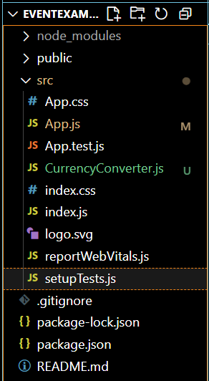

CODE:
App.js
import React from 'react';
import CurrencyConverter from './CurrencyConverter';

class App extends React.Component {
constructor(props) {
super(props);
this.state = {
count: 0
};
}

// Method 1: Increment Counter
increment = () => {
this.setState({ count: this.state.count + 1 });
};

// Method 2: Say Hello
sayHello = () => {
alert("Hello! React Event Triggered.");
};

// Method to combine both
handleIncrement = () => {
this.increment();
this.sayHello();
};

// Decrement Method
handleDecrement = () => {
this.setState({ count: this.state.count - 1 });
};

// Function with argument
sayWelcome = (msg) => {
alert("Message: " + msg);
};

// Synthetic Event handler
onPress = (e) => {
e.preventDefault(); // Prevents default behavior
alert("I was clicked!");
};

render() {
return (
<div style={{ padding: '20px', fontFamily: 'Arial' }}>
<h1>React Event Handling Example</h1>

<h2>Counter: {this.state.count}</h2>
<button onClick={this.handleIncrement}>Increment</button>{' '}
<button onClick={this.handleDecrement}>Decrement</button>

<hr />

<button onClick={() => this.sayWelcome("Welcome to React!")}>Say Welcome</button>

<hr />

<button onClick={this.onPress}>Synthetic Event Button</button>

<hr />

<CurrencyConverter />
</div>
);
}
}

export default App;

CurrencyConverter.js
import React, { Component } from 'react';

class CurrencyConverter extends Component {
constructor(props) {
super(props);
this.state = {
rupees: '',
euro: ''
};
}

handleInputChange = (e) => {
this.setState({ rupees: e.target.value });
};

handleSubmit = (e) => {
e.preventDefault();
const euroValue = (this.state.rupees / 90).toFixed(2); // Example conversion rate
this.setState({ euro: euroValue });
};

render() {
return (
<div>
<h2>Currency Converter (INR to Euro)</h2>
<form onSubmit={this.handleSubmit}>
<input
type="number"
placeholder="Enter INR"
value={this.state.rupees}
onChange={this.handleInputChange}
/>
<button type="submit">Convert</button>
</form>

{this.state.euro && (
<p>
₹{this.state.rupees} = €{this.state.euro}
</p>
)}
</div>
);
}
}

export default CurrencyConverter;

OUTPUT:

